DNA
DNA is Deoxyribonucleic Acid. DNA is a chemical. DNA is responsible for the production of proteins within a cell. Proteins are the `doers’ and `builders’ of your body – so by controlling the protein that are made, DNA controls the way your body looks and the way it functions – simple really!
DNA is found in the nucleus of every cell in your body. DNA carries the codes (sometimes called blueprints) for making all the proteins that exist in your body. So, in theory every cell can make every protein. However, cells in your body are usually very specialised so they make vey specific proteins. This means different cells use different parts of the DNA to make the proteins which that the cell needs.
Structure of DNA – A very specific and unusual structure
- Double helix structure – like a twisted ladder.
- The two ladder uprights are made of a chain of alternating sugar (like glucose) and phosphate units. These uprights act as support and structure and not provide any genetic code.
- The “ladder’s” rungs are what provide the genetic code. Each rung is made of two molecules called nitrogen bases. There are actually only 4 different nitrogen base units which occur in DNA:
A = adenosine T = thymine C = cytosine G = guanine
- The four bases actually pair up is specific ways. A (adenosine) is always paired to T (thymine), and these rungs can be AT or TA. C (cytosine) is always paired with G (guanine), and the rung can be CG or GC. The order in which the rungs occur provide the code for making the proteins. So, there are actually only four different rung structures which make up the DNA genetic code. A and T are said to be complementary bases, as are C and G

Some DNA Terminology
A gene is a section of DNA which carries the right sequence of bases to make a protein. The proteins are the things that run your body and cause your inherited characteristics. Each gene controls the production of one protein. A single complete strand of DNA is called a chromosome, may have thousands of genes along its length. In between the genes are codes to stop making proteins and then start again. Chromosomes are very long so they are “folded up” on themselves four ways (called quaternary folding) so that they fit into the nucleus of the cell.
Humans have 46 chromosomes. 23 chromosomes are received from each parent – thus two very important points about your DNA should be obvious.
    - Your DNA is exactly 50% of your dad’s DNA and 50% of your Mum’s DNA.
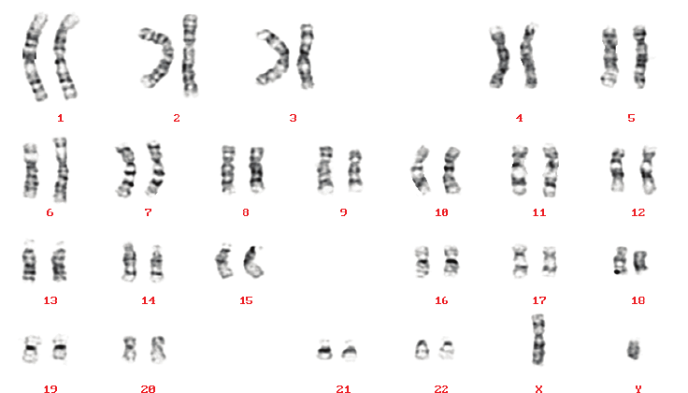
    - Each chromosome from your parent (each one of the 23) has a matching chromosome from the other parent. You don’t really have 46 different chromosomes – you have 23 pairs of chromosomes. Each pair is one chromosome from your mum and one from your dad – these will be very, very similar, but not identical. This means there should be two copies of every gene. This is very useful because if one copy of a gene does not work, you will have a backup copy which hopefully will make the correct protein.
Your Karyotype is your individual collection of 46 chromosomes (see picture).

